INFO 605 Project: Prosthesis Selection Database (Fall 2025)
Team 1: Silas McAllister-Spooner, Virginia Muthard, and Phillip Roman
This project catalogues the design and creation of a relational database which identifies success rates for various levels of lower limb prostheses including foot, knee, and hip component options.
- Executive Summary
This report documents the end-to-end development of the Prosthesis Selection Database, a project designed to transition prosthetic care from subjective, disconnected workflows into a data-driven clinical practice. Currently, the lack of a centralized system means treatment decisions often rely on anecdotal experience rather than standardized evidence, leading to potential inefficiencies in component selection and device adjustments. Our team addressed this operational gap by constructing a relational database capable of tracking patient demographics, component details, and clinical outcomes for unilateral lower-limb amputations. The goal was not simply to digitize records, but to create an analytical foundation that allows clinicians to correlate specific prosthetic components—such as feet, knees, and hips—with long-term patient success rates and satisfaction scores.
The technical execution followed an iterative design methodology, progressing from initial requirement analysis to a fully normalized logical schema hosted on an Oracle Database. A major focus of our work involved translating complex real-world medical constraints into rigid database logic. We utilized Entity-Relationship modeling to enforce strict business rules, ensuring that the database accurately reflects the physical dependencies of different amputation levels, specifically Transtibial, Transfemoral, and Hip Disarticulation. This structure ensures data integrity by preventing invalid component associations—such as assigning a knee unit to a patient whose amputation level does not require one—while maintaining HIPAA-compliant security structures to protect sensitive patient data.
Beyond the structural design, this report details the practical application of the database through SQL implementation and data manipulation. We demonstrated the system’s analytical value by executing complex queries that solved specific business problems: identifying satisfaction trends across different material types, analyzing composite scores relative to patient age groups, and flagging high-severity cases for prioritized care. These queries prove that the database can successfully transform raw transactional data into actionable insights, moving beyond simple storage to support complex clinical decision-making regarding material durability and demographic suitability.
Ultimately, this project serves as the architectural proof-of-concept for a future knowledge-based recommender system. By successfully navigating the challenges of defining scope and enforcing referential integrity, we have established a scalable framework that can grow with the clinic's needs. The result is a robust system that not only streamlines current operations but provides the structured historical data necessary to optimize patient satisfaction and treatment efficacy in the long term.
- Project Statement
  - Context and Overall Goals
The primary objective is to design a relational database for a prosthetics clinic that tracks patient information, prosthetic device details, and clinical outcomes. The system will serve as an evidence-based foundation for a future knowledge-based recommender system, enabling clinicians to query component recommendations and reduce clinical inefficiencies. Clinicians will be able to utilize this database to make educated decisions about treatment when providing a prosthetic evaluation and recommendation for a patient.
Currently, component selection and device adjustments can be inefficient and lack a standardized, evidence-based approach. This database is essential because it will capture the necessary data to analyze the effectiveness of different prosthetic components for various patient profiles. It will help clinicians make more informed decisions, moving beyond routine choices to optimize patient care and satisfaction. For example, users will be able to search for a specific prosthesis including its components, and then select and view its success rate in respect to the age and gender demographic of the patient. The database must store information specific to the success and implementation of each instance - specifically the primary clinician, the patient information, the amount of follow ups and respective severity, the amputation level, and a resulting composite score.
The database would be accessed through an application/website user interface which would require username/password credentials within a company for access. More specifically, the database will be specifically for medical professionals, gaining access via the creation of a username and password as well as receiving a unique user key through their employing clinic. The manipulation of the database itself would be maintained on the backend through script integration that would encrypt and pull fresh data at routine intervals (e.g. every night) from the user interface. This structure allows for queries and views to occur but prevents accidental manipulation of data by end-users. It also ensures that patient privacy and HIPAA compliance are maintained in the database, with only those users who are HIPAA compliant able to access it.
  - Scope of the Project
In-Scope
The database will manage information about Patient, Surgeon, and Clinician. The data recorded on Patient is solely on unilateral, lower limb amputations. The amputations are categorized by one of three amputation levels (e.g., Transtibial, Transfemoral, or Hip Disarticulation) and correspond to the required components of the Prosthesis (Foot, Knee, Hip). This database will track the details of each Prosthesis, including its component parts (Foot, Knee, Hip) as well as its associated clinical record (e.g., fitting date, adjustment history, and outcome scores).

Out-Scope
This project will not include a scheduling or appointments system, billing, insurance, or component inventory. The database is focused solely on the data needed to support clinical decision-making.
- Requirements Specification
  - Analysis of Current System
This analysis evaluates the current operational state of the hypothetical prosthetics clinical practice prior to the implementation of the new database solution. Currently, the practice functions without a centralized relational database management system. Patient records, prosthetic component inventories, and clinical outcome scores are managed through disparate, non-integrated methods, likely consisting of manual paper records or disconnected spreadsheet files (e.g., Excel).
As noted in the project context, this is a brand-new database initiative, and no historical relational data exists. The current lack of a unified system means that component selection and device adjustments rely heavily on subjective clinician experience rather than standardized data. There is currently no mechanism to query long-term success rates of specific component combinations (Foot, Knee, Hip) against patient demographics, resulting in clinical inefficiencies and a lack of evidence-based decision support.
  - Data Requirements
- Entities: Patient, Clinician, Surgeon, Prosthesis, Visits, Foot, Knee, Hip.
- Attributes: Patient Name, Birthdate, Gender, Address, Phone, Prosthesis ID, Material Type, Component Details (Manufacturer, Make), Visit Date, Visit Severity, Outcome Scores
- Data types: Strings (VARCHAR), Dates (DATE), Numbers (INT, DEC).
- Keys: Primary Keys (e.g., patientId, prxId) and Foreign Keys linking entities (e.g., surgeonId in Patient table).

  - Business Rules and Logic
- Each Patient is associated with exactly one Surgeon, but a Surgeon can have many Patients.
- Each Patient sees one Clinician, but a Clinician can have many Patients.
- Each Clinician can fit many Prostheses, but each Prosthesis is fit by only one Clinician.
- Each Prosthesis must be associated with exactly one Patient.
- Each Prosthesis must have exactly one Foot component.
- Each Prosthesis for a Transfemoral or Hip Disarticulation amputation must also have exactly one Knee component.
- Each Prosthesis for a Hip Disarticulation amputation must also have exactly one Hip component.
- Each component (Foot, Knee, Hip) can be used in many different Prostheses.
  - Other Assumptions
- Phone numbers follow a standard format.
- Each patient has only one clinician.
- Materials list is limited to aluminum, titanium, or stainless steel
- Birthdates are valid and stored as real dates.
- Patients are at least 18 years old but not older than 90 years old.
- All IDs are unique and generated by the system.
- This is a brand-new database, for which no historical data exists beyond the current prosthesis.
- Patient can have surgery in any address location.
- Patients may travel for prosthetic care; therefore, surgery and prosthetic care locations may differ.
- Patient can only have one amputation at one of the three specified levels (TT, TF, HD).
- Patient can only have one prosthesis that they receive service/care for at any given point (i.e., a new prosthesis would trigger a new fitting date for the patient).
- Visit Integrity: A visit date must occur on or before the current system date (no future visits) and must occur after the patient's birth date.
- Pre-fitting Exclusion: Visits are only recorded for adjustments or consultations related to an active treatment plan

  - The Way We Solved the Problem
The team approached the solution by first analyzing the existing synthetic dataset provided by team member Virginia Muthard. Using this data as a foundation, we defined the scope of the project and established the initial business rules and constraints.
The design process followed an iterative prototyping methodology:
- Conceptual Design: We constructed a Conceptual Entity-Relationship Diagram (ERD), defining entities, primary keys, relationships, and cardinality constraints.
- Logical Design: We translated the conceptual model into a Logical ERD and Referential Schema.
- Iterative Refinement: The design underwent multiple revisions. These revisions were necessitated effectively by two factors: constraints discovered within the data itself and strict adherence to real-world domain business rules (e.g., ensuring specific amputation levels corresponded to the correct number of components).

  - The Way We Obtained (Created) the Data
The data for this project was obtained by team member Virginia Muthard. It is a synthetic dataset originally created for use in a "Recommender Systems" course. The dataset was selected because it provides realistic, structured data regarding patient demographics, prosthetic components, and clinical outcome scores, allowing for complex querying without compromising real-patient privacy (HIPAA compliance).
  - Each Member’s Hardware and Software:
- Virginia Muthard: ASUS VivoBook laptop w/AMD Ryzen 9 7940HS (8 cores, up to 4 GHz) and Radeon 780M integrated graphics GPU, 40 GB RAM, 64-bit Windows 11 OS. Running Oracle through SQL Developer local install.
- Silas McAllister-Spooner: B650 GAMING X AX V2 w/AMD Ryzen 7 3800 Mhz 8 cores and Radeon RX 7800 XT Graphics Card, 32 GB RAM, 64-bit Windows 11 OS. Running Oracle through SQL Developer local install.
- Phillip Roman: MacBook Pro running a Docker container to host Oracle Database Standard version 19c. The database is interfaced using VS Code with the SQL Developer extension.

- Conceptual Design
  - Conceptual Model (ERD)
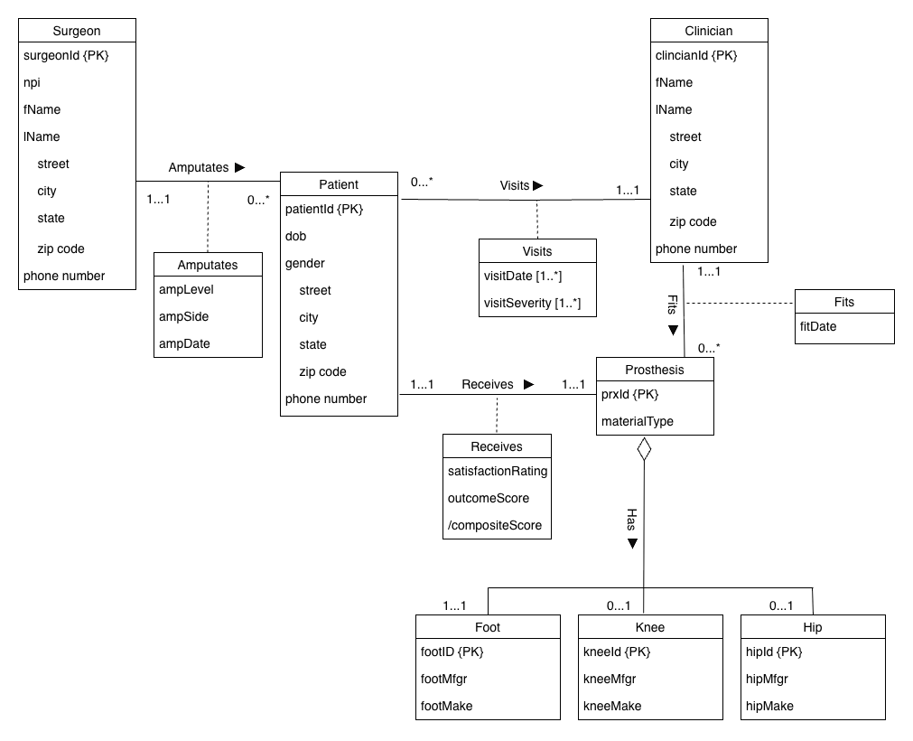

  - Explanation of ERD
The Conceptual Entity-Relationship Diagram (ERD) models the data requirements for the Prosthesis Selection Database, focusing on the relationships between clinical staff, patients, and prosthetic devices. The model is built around five primary entities: Surgeon, Patient, Clinician, Visits, and Prosthesis, along with three component entities: Foot, Knee, and Hip.
The Patient entity serves as a central hub. Relationships are structured to reflect the clinic's operational model. A Surgeon performs an amputation on a patient, represented by the Amputates relationship. This is a one-to-many relationship, where one surgeon can operate on many patients, but each patient record is associated with the single surgeon who performed their specific amputation. Similarly, the Patient and Clinician entities are connected via a Visits relationship. While a clinician manages many patients, the model enforces that a patient is assigned to exactly one primary clinician for their ongoing care. The Visits entity serves as an association class here, capturing the multi-valued attributes of visitDate and visitSeverity to track the history of interactions without violating the atomic attribute rule of the primary entities.
The Prosthesis entity is linked to the Patient via the Receives relationship. This is modeled as a one-to-one relationship, reflecting the business rule that a patient is actively treated with only one prosthetic device at a time. The Receives association entity captures the outcome metrics, specifically the satisfactionRating and outcomeScore, along with a derived attribute, /compositeScore, which calculates the overall success of that specific device-patient pairing. The Prosthesis is also linked to the Clinician via the Fits relationship, indicating the date the clinician fitted the prosthesis.
Finally, the physical composition of the prosthetic is modeled using an aggregation relationship. The Prosthesis is the "whole," while Foot, Knee, and Hip are the "parts." The cardinalities here reflect clinical reality: every lower-limb prosthesis must have a Foot (1..1), but Knee and Hip components are optional (0..1) depending on the patient's amputation level (e.g., a Transtibial patient requires a foot but not a knee or hip).
  - Assumptions and Terminology
To accurately interpret the Conceptual ERD, several key assumptions regarding the business rules and domain scope must be understood.
First, the cardinality for the relationship between Patient and Clinician, as well as Patient and Prosthesis, is strictly modeled as one-to-one (1..1) from the patient's perspective. This assumption is based on an "Active Care" business rule. The database is designed to capture the current state of treatment; therefore, a patient is assigned to only one managing clinician at any given time, and they possess only one active primary prosthesis. While patients may historically have had other clinicians or devices, this system focuses on the current active pairing to determine immediate success rates.
Second, we assume that 'address' is a composite attribute for entities such as Patient, Surgeon, and Clinician. Therefore, each address is flattened into simple attributes (Street, City, State, Zip Code) within the respective entities to streamline the design, as the clinic does not require complex spatial queries or multiple addresses per person.
The diagram also utilizes specific domain acronyms and abbreviations for brevity: NPI (Surgeon Table): National Provider Identifier. This is a unique 10-digit identification number issued to health care providers in the United States. prx (Prosthesis Table): An abbreviation for "Prosthesis," used in the primary key prxId. compMfgr (Foot, Knee, Hip Tables): An abbreviation for "Component Manufacturer," referring to the company that produced the specific part. compModel (Foot, Knee, Hip Tables): An abbreviation for "Component Model," referring to the specific product name or number. /compositeScore (Receives Entity): The forward slash indicates this is a derived attribute. It represents a calculated value derived from the formula: (outcomeScore + (satisfactionRating * 20)) / 2. This normalizes the 5-point satisfaction scale to the 100-point outcome scale for a unified success metric.
- Relational Schema
  - Relational Schema Translation
- Identify Entity Types:
  - Strong
    - Patient
    - Clinician
    - Prosthesis
    - Surgeon
    - Foot
    - Knee
    - Hip
  - Weak/Multi-value
    - Visits
  - Super/Subclass
    - N/A
- Identify Relationship Types for Strong Entities:
  - Many-to-Many: None
  - One-to-Many:
    - Surgeon/Patient
    - Clinician/Patient
    - Clinician/Prosthesis
    - Foot/Prosthesis
    - Knee/Prosthesis
    - Hip/Prosthesis
  - One-to-One: Patient/Prosthesis
  - n-ary: N/A
- Identify Relationship Types for Weak Entities:
  - Many-to-Many: N/A
  - One-to-Many: N/A
  - One-to-One: N/A
  - n-ary: N/A
- Identify Special Attributes
  - Composite Attributes:
    - address (Patient)
    - address (Clinician)
    - address (Surgeon)
    - clinicianName (Clinician)
    - surgeonName (Surgeon)
    - patientName (Patient)
  - Multi-valued Attributes:
    - visitDate(Visits)
    - visitSeverity(Visits)
  - Derived Attributes:
    - compositeScore (Prosthesis)
- Translate
  - Strong Entity Types
    - PATIENT()
    - CLINICIAN()
    - PROSTHESIS()
    - SURGEON()
    - FOOT()
    - KNEE()
    - HIP()
  - Many-to-Many Relationships
    - N/A
  - One-to-Many Relationships
    - clinicianId gets added to PATIENT() and PROSTHESIS()
    - footId gets added to PROSTHESIS()
    - kneeId gets added to PROSTHESIS()
    - hipId gets added to PROSTHESIS()
    - surgeonId gets added to PATIENT()
  - One-to-One Relationships
    - patientId gets added to PROSTHESIS()
  - n-ary Relationships
    - N/A
  - Weak Entities
    - N/A
  - Migration of Relationship Attributes
    - fitDate gets added to PROSTHESIS()
    - outcomeScore gets added to PROSTHESIS()
    - satisfactionRating gets added to PROSTHESIS()
    - compositeScore gets added to PROSTHESIS()
    - ampLevel gets added to PATIENT()
    - ampDate gets added to PATIENT()
    - ampSide gets added to PATIENT()
  - Multi-valued Attributes
    - visitDate gets added to VISITS()
    - visitSeverity gets added to VISITS()
  - Superclasses and Subclasses
    - N/A

  - Relational Schema
SURGEON(surgeonId, npi, fName, lName, street, city, state, zip, phone)
CLINICIAN(clinicianId, fName, lName, street, city, state, zip, phone)
FOOT(footId, footMfgr, footMake)
KNEE(kneeId, kneeMfgr, kneeMake)
HIP(hipId, hipMfgr, hipMake)
PATIENT(patientId, dob, gender, street, city, state, zip, phone, surgeonId, clinicianId, ampLevel, ampDate, ampSid)
Foreign key surgeonId references SURGEON(surgeonId)
Foreign key clinicianId references CLINICIAN(clinicianId)
VISITS(clinicianId, patientId, visitDate, visitSeverity)
Foreign key patientId references PATIENT(patientId)
Foreign key clinicianId references CLINICIAN(clinicianId)
PROSTHESIS(prxId, materialType, patientId, clinicianId, footId, kneeId, hipId, outcomeScore, satisfactionRating, compositeScore, fitDate)
Foreign key patientId references PATIENT(patientId)
Foreign key clinicianId references CLINICIAN(clinicianId)
Foreign key footId references FOOT(footId)
Foreign key kneeId references KNEE(kneeId)
Foreign key hipId references HIP(hipId)

  - Logical ERD
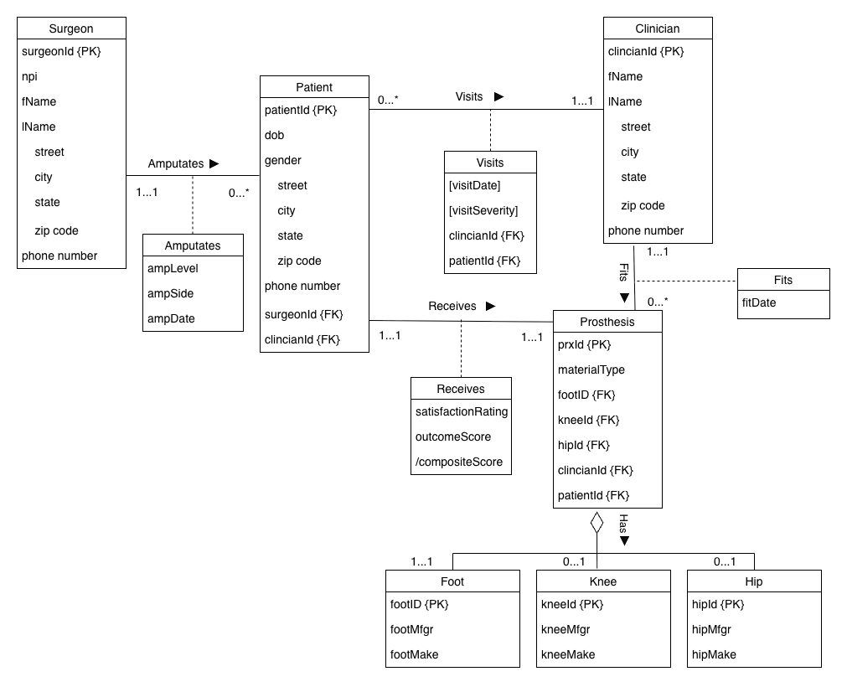

- Data Dictionary
SURGEON
contains information about specific surgeons performing amputations on patients.
Attribute Name | Description | Datatype | Domain | Nullable | PK | FK
surgeonId | Unique, system-assigned numerical identifier of surgeon | NUMBER(3) | 0-999 | N | Y | N
npi | Unique, national provider identification number; alternate key | CHAR(10) | 0000000001- 9999999999 | N | N | N
fName | First name of surgeon | VARCHAR2(12) | All | N | N | N
lName | Last name of surgeon | VARCHAR2(20) | All | N | N | N
street | Surgeon’s office physical street address | VARCHAR2(48) | All | N | N | N
city | Surgeon’s office city | VARCHAR2(25) | All | N | N | N
state | Surgeon’s office state (2-character abbreviation) | CHAR(2) | All | N | N | N
zip | Surgeon’s office 5-digit numerical zip code | CHAR(5) | 00000-99999 | N | N | N
phone | Surgeon’s office 10-digit phone number | CHAR(10) | All | N | N | N

CLINICIAN
contains information about specific clinical providers of prosthetic services (fitting and servicing).
Attribute Name | Description | Datatype | Domain | Nullable | PK | FK
clinicianId | Unique, system-assigned numerical identifier of clinician | NUMBER(3) | 0-999 | N | Y | N
fName | First name of clinician | VARCHAR2(12) | All | N | N | N
lName | Last name of clinician | VARCHAR2(20) | All | N | N | N
street | Clinician’s clinic physical street address | VARCHAR2(48) | All | N | N | N
city | Clinician’s clinic city | VARCHAR2(25) | All | N | N | N
state | Clinician’s clinic state (2-character abbreviation) | CHAR(2) | All | N | N | N
zip | Clinician’s clinic 5-digit numerical zip code | CHAR(5) | 00000-99999 | N | N | N
phone | Clinician’s clinic 10-digit phone number | CHAR(10) | All | N | N | N

FOOT
contains information about specific prosthetic foot components.
Attribute Name | Description | Datatype | Domain | Nullable | PK | FK
footId | Unique, system-assigned numerical identifier of foot component for use in prxId | NUMBER(3) | 0-999 | N | Y | N
footMfgr | Manufacturer of footId | VARCHAR2(16) | All | N | N | N
footMake | Make of footId | VARCHAR2(48) | All | N | N | N

KNEE
contains information about specific prosthetic knee components.
Attribute Name | Description | Datatype | Domain | Nullable | PK | FK
kneeId | Unique, system-assigned numerical identifier of knee component for use in prxId | NUMBER(3) | 0-999 | N | Y | N
kneeMfgr | Manufacturer of kneeId | VARCHAR2(16) | All | N | N | N
kneeMake | Make of kneeId | VARCHAR2(48) | All | N | N | N

HIP
contains information about specific prosthetic hip components.
Attribute Name | Description | Datatype | Domain | Nullable | PK | FK
hipId | Unique, system-assigned numerical identifier of hip component for use in prxId | NUMBER(3) | 0-999 | N | Y | N
hipMfgr | Manufacturer of hipId | VARCHAR2(16) | All | N | N | N
hipMake | Make of hipId | VARCHAR2(48) | All | N | N | N

PATIENT
contains information about specific users who receive prosthetic devices and services.
Attribute Name | Description |  |  | Datatype |  | Domain |  | Nullable |  | PK |  | FK
patientId | Unique, system-assigned numerical identifier of patient |  |  | NUMBER(8) |  | 0-99999999 |  | N |  | Y |  | N
dob | Date patient was born |  |  | DATE |  | Only after 1/1/1935 |  | N |  | N |  | N
gender | Gender assigned to patient at birth (M or F) |  |  | CHAR(1) |  | M or F |  | N |  | N |  | N
street | Patient’s home physical street address |  |  | VARCHAR2(48) |  | All |  | N |  | N |  | N
city | Patient's home city |  |  | VARCHAR2(25) |  | All |  | N |  | N |  | N
state | Patient's home state (2-character abbreviation) |  |  | CHAR(2) |  | All |  | N |  | N |  | N
zip | Patient's home 5-digit numerical zip code |  |  | CHAR(5) |  | 00000-99999 |  | N |  | N |  | N
phone | Patient's home 10-digit phone number |  |  | CHAR(10) |  | All |  | N |  | N |  | N
surgeonId | Unique identifier for surgeon who performed amputation of patient’s limb |  |  | NUMBER(3) |  | 0-999 |  | N |  | N |  | Y
clinicianId | Unique identifier for clinician who fit/serviced prosthetic device for patient |  |  | NUMBER(3) |  | 0-999 |  | N |  | N |  | Y
ampLevel | Level of amputation of patientId by surgeonId (transtibial, transfemoral, hip disarticulation) |  |  | CHAR(2) |  | [TT, TF, HD] |  | N |  | N |  | N
ampDate | Date of amputation of patientId by surgeonId |  |  | DATE |  | >dob + 18 years |  | N |  | N |  | N
ampSide | Side of amputation of patientId by surgeonId (L or R) |  |  | CHAR(1) |  | L or R |  | N |  | N |  | N
VISITS
contains information about specific visits in relation to patient//clinician.
Attribute Name |  | Description | Datatype |  | Domain |  | Nullable |  | PK |  | FK
patientId |  | Unique, system-assigned numerical identifier of patient | NUMBER(8) |  | 0-99999999 |  | N |  | Y |  | Y
clinicianId |  | Unique, system-assigned numerical identifier of clinician | NUMBER(3) |  | 0-999 |  | N |  | Y |  | Y
visitDate |  | Specific date on which patient visits clinicianId | DATE |  | Must be > fitDate AND <= Current Date |  | N |  | Y |  | N
visitSeverity |  | Severity of visitDate with clinicianId  (1-3, Low-High) | NUMBER(1) |  | [1-3] |  | N |  | N |  | N

PROSTHESIS
contains information about specific prosthetic device received by specific user.
Attribute Name | Description | Datatype | Domain | Nullable | PK | FK
prxId | Unique, system-assigned numerical identifier of prosthesis | NUMBER(8) | 0-99999999 | N | Y | N
materialType | Material used to assemble prosthetic components of prxId | VARCHAR2(16) | Aluminum, Titanium, Stainless Steel | N | N | N
patientId | Unique identifier of patient receiving prxId | NUMBER(8) | 0-99999999 | N | N | Y
clinicianId | Unique identifier of clinician fitting prxId on patientId | NUMBER(3) | 0-999 | N | N | Y
footId | Unique identifier of prosthetic foot used in prxId (all must have) | NUMBER(3) | All | N | N | Y
kneeId | Unique identifier of prosthetic knee used in prxId (optional) | NUMBER(3) | All | Y | N | Y
hipId | Unique identifier of prosthetic hip used in prxId (optional) | NUMBER(2) | All | Y | N | Y
outcomeScore | Score given to prxId based on patientId’s functional performance with prxId (0-100) | NUMBER(4,1) | [0-100] | N | N | N
satisfactionRating | Score given to prxId by patientId based on their satisfaction with prxId (1-5) | NUMBER(2,1) | [0-5] | N | N | N
compositeScore | Composite score averaging functional outcome and patient satisfaction, normalized to a 100-point scale. | NUMBER(4,1) | Derived. (outcomeScore + (satisfactionRating * 20)) / 2 | N | N | N
fitDate | Specific date on which patient receives prxId | DATE | Must be > ampDate AND >1/1/2022 | N | N | N

- Database Implementation
  - CREATE TABLE Commands
-- ============================================
-- TABLE 1: SURGEON (No Foreign Keys)
-- ============================================
CREATE TABLE Surgeon (
surgeonId NUMBER(3) PRIMARY KEY,
npi CHAR(10) NOT NULL UNIQUE,
fName VARCHAR2(12) NOT NULL,
lName VARCHAR2(20) NOT NULL,
street VARCHAR2(48) NOT NULL,
city VARCHAR2(25) NOT NULL,
state CHAR(2) NOT NULL,
zip CHAR(5) NOT NULL,
phone CHAR(10) NOT NULL
);

-- ============================================
-- TABLE 2: CLINICIAN (No Foreign Keys)
-- ============================================
CREATE TABLE Clinician (
clinicianId NUMBER(3) PRIMARY KEY,
fName VARCHAR2(12) NOT NULL,
lName VARCHAR2(20) NOT NULL,
street VARCHAR2(48) NOT NULL,
city VARCHAR2(25) NOT NULL,
state CHAR(2) NOT NULL,
zip CHAR(5) NOT NULL,
phone CHAR(10) NOT NULL
);

-- ============================================
-- TABLE 3: FOOT (No Foreign Keys)
-- ============================================
CREATE TABLE Foot (
footId NUMBER(3) PRIMARY KEY,
footMfgr VARCHAR2(16) NOT NULL,
footMake VARCHAR2(48) NOT NULL
);

-- ============================================
-- TABLE 4: KNEE (No Foreign Keys)
-- ============================================
CREATE TABLE Knee (
kneeId NUMBER(3) PRIMARY KEY,
kneeMfgr VARCHAR2(16) NOT NULL,
kneeMake VARCHAR2(48) NOT NULL
);

-- ============================================
-- TABLE 5: HIP (No Foreign Keys)
-- ============================================
CREATE TABLE Hip (
hipId NUMBER(2) PRIMARY KEY,
hipMfgr VARCHAR2(16) NOT NULL,
hipMake VARCHAR2(48) NOT NULL
);

-- ============================================
-- TABLE 6: PATIENT (Foreign Keys: surgeonId, clinicianId)
-- ============================================
CREATE TABLE Patient (
patientId NUMBER(8) PRIMARY KEY,
dob DATE NOT NULL,
gender CHAR(1) NOT NULL,
street VARCHAR2(48) NOT NULL,
city VARCHAR2(25) NOT NULL,
state CHAR(2) NOT NULL,
zip CHAR(5) NOT NULL,
phone CHAR(10) NOT NULL,
surgeonId NUMBER(3) NOT NULL,
clinicianId NUMBER(3) NOT NULL,
ampLevel CHAR(2) NOT NULL,
ampDate DATE NOT NULL,
ampSide CHAR(1) NOT NULL,

CONSTRAINT chk_patient_gender CHECK (gender IN ('M', 'F')),
CONSTRAINT chk_patient_ampLevel CHECK (ampLevel IN ('TT', 'TF', 'HD')),
CONSTRAINT chk_patient_ampSide CHECK (ampSide IN ('L', 'R')),
CONSTRAINT chk_patient_dob CHECK (dob > DATE '1935-01-01'),
CONSTRAINT chk_patient_ampDate CHECK (ampDate > dob + INTERVAL '18' YEAR),
CONSTRAINT fk_patient_surgeon FOREIGN KEY (surgeonId) REFERENCES Surgeon(surgeonId),
CONSTRAINT fk_patient_clinician FOREIGN KEY (clinicianId) REFERENCES Clinician(clinicianId)
);

-- ============================================
-- TABLE 7: VISITS (Foreign Keys: patientId, clinicianId)
-- Composite PK: (patientId, clinicianId, visitDate)
-- Allows: Multiple visits per patient-clinician pair (on different dates)
-- Prevents: Same patient visiting same clinician twice on same day
-- ============================================

CREATE TABLE Visits (
patientId NUMBER(8) NOT NULL,
clinicianId NUMBER(3) NOT NULL,
visitDate DATE NOT NULL,
visitSeverity NUMBER(1) NOT NULL,

-- Composite Primary Key
CONSTRAINT pk_visits PRIMARY KEY (patientId, clinicianId, visitDate),
CONSTRAINT chk_visits_severity CHECK (visitSeverity BETWEEN 1 AND 3),
CONSTRAINT fk_visits_patient FOREIGN KEY (patientId) REFERENCES Patient(patientId),
CONSTRAINT fk_visits_clinician FOREIGN KEY (clinicianId) REFERENCES Clinician(clinicianId)
);

-- ============================================
-- TABLE 8: PROSTHESIS (Foreign Keys: patientId, clinicianId, footId, kneeId, hipId)
-- *** INCLUDES 1:1 RELATIONSHIP ENFORCEMENT WITH UNIQUE CONSTRAINT ***
-- ============================================
CREATE TABLE Prosthesis (
prxId NUMBER GENERATED ALWAYS AS IDENTITY PRIMARY KEY,
materialType VARCHAR2(16) NOT NULL,
patientId NUMBER(8) NOT NULL UNIQUE, -- UNIQUE enforces 1:1 relationship!
clinicianId NUMBER(3) NOT NULL,
footId NUMBER(3) NOT NULL,
kneeId NUMBER(3),
hipId NUMBER(2),
outcomeScore NUMBER(4,1) NOT NULL,
satisfactionRating NUMBER(2,1) NOT NULL,
fitDate DATE NOT NULL,

-- Virtual Column for /compositeScore
compositeScore NUMBER(4,1) GENERATED ALWAYS AS ((outcomeScore + (satisfactionRating * 20)) / 2) VIRTUAL,

CONSTRAINT chk_prosthesis_materialType CHECK (materialType IN ('Aluminum', 'Titanium', 'Stainless Steel')),
CONSTRAINT chk_prosthesis_outcomeScore CHECK (outcomeScore BETWEEN 0 AND 100),
CONSTRAINT chk_prosthesis_satisfactionRating CHECK (satisfactionRating BETWEEN 0 AND 5),
CONSTRAINT chk_prosthesis_fitDate CHECK (fitDate > DATE '2022-01-01'),
CONSTRAINT fk_prosthesis_patient FOREIGN KEY (patientId) REFERENCES Patient(patientId),
CONSTRAINT fk_prosthesis_clinician FOREIGN KEY (clinicianId) REFERENCES Clinician(clinicianId),
CONSTRAINT fk_prosthesis_foot FOREIGN KEY (footId) REFERENCES Foot(footId),
CONSTRAINT fk_prosthesis_knee FOREIGN KEY (kneeId) REFERENCES Knee(kneeId),
CONSTRAINT fk_prosthesis_hip FOREIGN KEY (hipId) REFERENCES Hip(hipId)
);

  - INSERT INTO Commands
-- ================================
-- POPULATING SURGEON TABLE
-- ================================

INSERT INTO Surgeon (surgeonId,npi,fName,lName,street,city,state,zip,phone)
VALUES (2,'1913353035','Sandra','Cook','79007 Cedar Ct','Milford','VA','95181','8376026924');

INSERT INTO Surgeon (surgeonId,npi,fName,lName,street,city,state,zip,phone)
VALUES (3,'1335077679','Emily','Martin','28321 Redwood Ln','Salem','CO','59797','3556078785');

INSERT INTO Surgeon (surgeonId,npi,fName,lName,street,city,state,zip,phone)
VALUES (25,'1201981188','Barbara','Brooks','55618 Lexington St','Springfield','MI','27146','6278801832');

INSERT INTO Surgeon (surgeonId,npi,fName,lName,street,city,state,zip,phone)
VALUES (45,'2553395010','Joseph','Reed','28669 Fairview Circle','Hudson','WY','58351','4993241771');

-- ================================
-- POPULATING CLINICIAN TABLE
-- ================================
INSERT INTO Clinician (clinicianId,fName,lName,street,city,state,zip,phone)
VALUES (1,'Mason','Kramer','11527 Zephyr Commons','Quail Hollow','CT','15000','2035551842');

INSERT INTO Clinician (clinicianId,fName,lName,street,city,state,zip,phone)
VALUES (2,'Anthony','Alston','73804 Orchid Crossing','Crystal Lake','HI','27702','8085556721');

INSERT INTO Clinician (clinicianId,fName,lName,street,city,state,zip,phone)
VALUES (3,'Penelope','Dorsey','43851 Osprey Loop','Juniper Hills','AL','67183','2055559013');

INSERT INTO Clinician (clinicianId,fName,lName,street,city,state,zip,phone)
VALUES (4,'Ruby','Matthews','78428 Whisper Run','Alpine','MA','68762','7815554376');

INSERT INTO Clinician (clinicianId,fName,lName,street,city,state,zip,phone)
VALUES (5,'Charlotte','Graham','12258 Knoll Pass','Harbor Point','AK','48247','9075552304');

-- ================================
-- POPULATING FOOT TABLE
-- ================================
INSERT INTO Foot (footId,footMfgr,footMake)
VALUES (3,'Proteor','Agilix');

INSERT INTO Foot (footId,footMfgr,footMake)
VALUES (9,'Ossur','Proflex Pivot');

INSERT INTO Foot (footId,footMfgr,footMake)
VALUES (22,'Ottobock','Triton VS');

INSERT INTO Foot (footId,footMfgr,footMake)
VALUES (25,'Ottobock','Kintrol');

INSERT INTO Foot (footId,footMfgr,footMake)
VALUES (26,'Ottobock','Maverick Comfort AT');

-- ================================
-- POPULATING KNEE TABLE
-- ================================
INSERT INTO Knee (kneeId,kneeMfgr,kneeMake)
VALUES (4,'Proteor','Plie');

INSERT INTO Knee (kneeId,kneeMfgr,kneeMake)
VALUES (9,'Ossur','Navii Knee');

INSERT INTO Knee (kneeId,kneeMfgr,kneeMake)
VALUES (14,'Ossur','Total Knee 2100');

INSERT INTO Knee (kneeId,kneeMfgr,kneeMake)
VALUES (17,'Ossur','OP4 Knee');

-- ================================
-- POPULATING HIP TABLE
-- ================================
INSERT INTO Hip (hipId,hipMfgr,hipMake)
VALUES (1,'Ottobock','Modular Single Axis Hip');

INSERT INTO Hip (hipId,hipMfgr,hipMake)
VALUES (2,'Ottobock','Helix3D Hip');

INSERT INTO Hip (hipId,hipMfgr,hipMake)
VALUES (3,'Ottobock','Monocentric Hydraulic Hip');

-- ================================
-- POPULATING PATIENT TABLE
-- ================================
INSERT INTO Patient (patientId,dob,gender,street,city,state,zip,phone,surgeonId,clinicianId,ampLevel,ampDate,ampSide)
VALUES (14903955, DATE '1993-04-26','M','3717 Vista Ter','Quail Hollow','CT','15000','9595552766',25,1,'TF',DATE '2019-06-27','R');

INSERT INTO Patient (patientId,dob,gender,street,city,state,zip,phone,surgeonId,clinicianId,ampLevel,ampDate,ampSide)
VALUES (11902061, DATE '1946-11-01','F','7678 Otter Ter','Crystal Lake','HI','27702','8085554292',3,2,'TF',DATE '1973-03-25','R');

INSERT INTO Patient (patientId,dob,gender,street,city,state,zip,phone,surgeonId,clinicianId,ampLevel,ampDate,ampSide)
VALUES (29726645, DATE '2005-08-12','M','2303 Shady Dr, Apt 842','Juniper Hills','AL','67183','2515555377',45,3,'HD',DATE '2024-03-01','L');

INSERT INTO Patient (patientId,dob,gender,street,city,state,zip,phone,surgeonId,clinicianId,ampLevel,ampDate,ampSide)
VALUES (46040113, DATE '1942-05-17','M','7423 East Rd','Alpine','MA','68762','5085551975',3,4,'TF',DATE '1976-07-23','L');

INSERT INTO Patient (patientId,dob,gender,street,city,state,zip,phone,surgeonId,clinicianId,ampLevel,ampDate,ampSide)
VALUES (33535836, DATE '1964-07-24','F','6852 Robin Dr','Harbor Point','AK','48247','9075552640',2,5,'TT',DATE '1994-05-23','L');

-- ================================
-- POPULATING VISITS TABLE
-- ================================
-- ==
-- Patient 14903955
-- ==
INSERT INTO Visits (patientId,clinicianId,visitDate,visitSeverity)
VALUES (14903955, 1, DATE '2023-06-12', 3);

INSERT INTO Visits (patientId,clinicianId,visitDate,visitSeverity)
VALUES (14903955, 1, DATE '2025-09-21', 3);

INSERT INTO Visits (patientId,clinicianId,visitDate,visitSeverity)
VALUES (14903955, 1, DATE '2024-05-25', 3);

INSERT INTO Visits (patientId,clinicianId,visitDate,visitSeverity)
VALUES (14903955, 1, DATE '2025-07-11', 1);

-- ==
-- Patient 11902061
-- ==
INSERT INTO Visits (patientId,clinicianId,visitDate,visitSeverity)
VALUES (11902061, 2, DATE '2025-07-21', 1);

INSERT INTO Visits (patientId,clinicianId,visitDate,visitSeverity)
VALUES (11902061, 2, DATE '2025-03-18', 2);

INSERT INTO Visits (patientId,clinicianId,visitDate,visitSeverity)
VALUES (11902061, 2, DATE '2025-08-03', 1);

INSERT INTO Visits (patientId,clinicianId,visitDate,visitSeverity)
VALUES (11902061, 2, DATE '2025-09-23', 3);

INSERT INTO Visits (patientId,clinicianId,visitDate,visitSeverity)
VALUES (11902061, 2, DATE '2025-09-15', 3);

INSERT INTO Visits (patientId,clinicianId,visitDate,visitSeverity)
VALUES (11902061, 2, DATE '2025-03-03', 3);

INSERT INTO Visits (patientId,clinicianId,visitDate,visitSeverity)
VALUES (11902061, 2, DATE '2025-04-23', 1);

-- ==
-- Patient 29726645
-- ==
INSERT INTO Visits (patientId,clinicianId,visitDate,visitSeverity)
VALUES (29726645, 3, DATE '2025-07-17', 2);

INSERT INTO Visits (patientId,clinicianId,visitDate,visitSeverity)
VALUES (29726645, 3, DATE '2025-09-26', 3);

INSERT INTO Visits (patientId,clinicianId,visitDate,visitSeverity)
VALUES (29726645, 3, DATE '2024-11-04', 3);

INSERT INTO Visits (patientId,clinicianId,visitDate,visitSeverity)
VALUES (29726645, 3, DATE '2025-05-08', 2);

INSERT INTO Visits (patientId,clinicianId,visitDate,visitSeverity)
VALUES (29726645, 3, DATE '2024-10-07', 1);

INSERT INTO Visits (patientId,clinicianId,visitDate,visitSeverity)
VALUES (29726645, 3, DATE '2024-09-02', 1);

-- ==
-- Patient 46040113
-- ==
INSERT INTO Visits (patientId,clinicianId,visitDate,visitSeverity)
VALUES (46040113, 4, DATE '2025-10-01', 2);

INSERT INTO Visits (patientId,clinicianId,visitDate,visitSeverity)
VALUES (46040113, 4, DATE '2025-07-21', 1);

INSERT INTO Visits (patientId,clinicianId,visitDate,visitSeverity)
VALUES (46040113, 4, DATE '2025-06-04', 3);

INSERT INTO Visits (patientId,clinicianId,visitDate,visitSeverity)
VALUES (46040113, 4, DATE '2025-10-13', 1);

INSERT INTO Visits (patientId,clinicianId,visitDate,visitSeverity)
VALUES (46040113, 4, DATE '2025-07-31', 2);

INSERT INTO Visits (patientId,clinicianId,visitDate,visitSeverity)
VALUES (46040113, 4, DATE '2025-06-22', 2);

-- ==
-- Patient 33535836
-- ==
INSERT INTO Visits (patientId,clinicianId,visitDate,visitSeverity)
VALUES (33535836, 5, DATE '2025-03-13', 2);

INSERT INTO Visits (patientId,clinicianId,visitDate,visitSeverity)
VALUES (33535836, 5, DATE '2025-09-10', 1);

INSERT INTO Visits (patientId,clinicianId,visitDate,visitSeverity)
VALUES (33535836, 5, DATE '2025-04-19', 1);

INSERT INTO Visits (patientId,clinicianId,visitDate,visitSeverity)
VALUES (33535836, 5, DATE '2025-09-20', 2);

-- ================================
-- POPULATING PROSTHESIS TABLE
-- ================================
INSERT INTO Prosthesis (materialType,patientId,clinicianId,footId,kneeId,hipId,outcomeScore,satisfactionRating,fitDate)
VALUES ('Aluminum',14903955,1,25,9,NULL,78.2,3.5,DATE '2023-04-11');

INSERT INTO Prosthesis (materialType,patientId,clinicianId,footId,kneeId,hipId,outcomeScore,satisfactionRating,fitDate)
VALUES ('Titanium',11902061,2,9,17,NULL,60,4.7,DATE '2025-02-25');

INSERT INTO Prosthesis (materialType,patientId,clinicianId,footId,kneeId,hipId,outcomeScore,satisfactionRating,fitDate)
VALUES ('Aluminum',29726645,3,3,4,3,72.7,3.8,DATE '2024-07-11');

INSERT INTO Prosthesis (materialType,patientId,clinicianId,footId,kneeId,hipId,outcomeScore,satisfactionRating,fitDate)
VALUES ('Stainless Steel',46040113,4,22,14,NULL,61,4.8,DATE '2025-05-29');

INSERT INTO Prosthesis (materialType,patientId,clinicianId,footId,kneeId,hipId,outcomeScore,satisfactionRating,fitDate)
VALUES ('Stainless Steel',33535836,5,26,NULL,NULL,71,2.9,DATE '2024-05-10');

  - Current Database State (SELECT * FROM table OUTPUT)
SELECT * FROM Surgeon
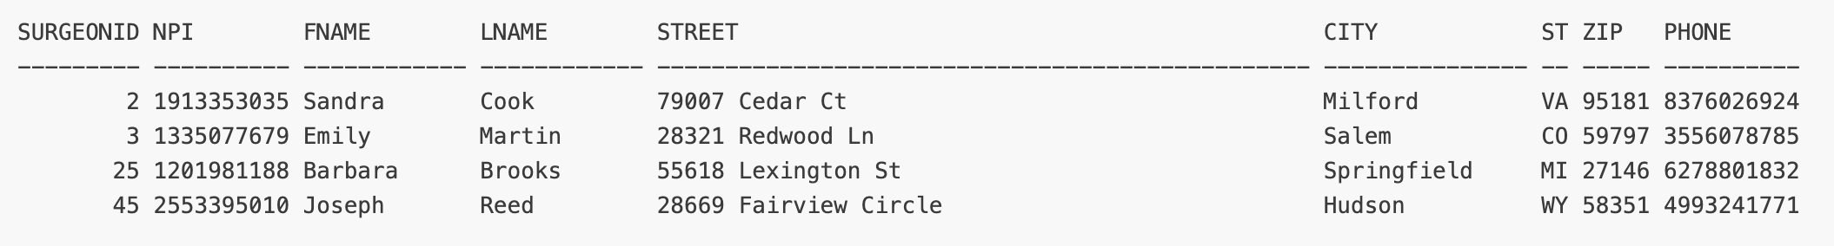

SELECT * FROM Clinician
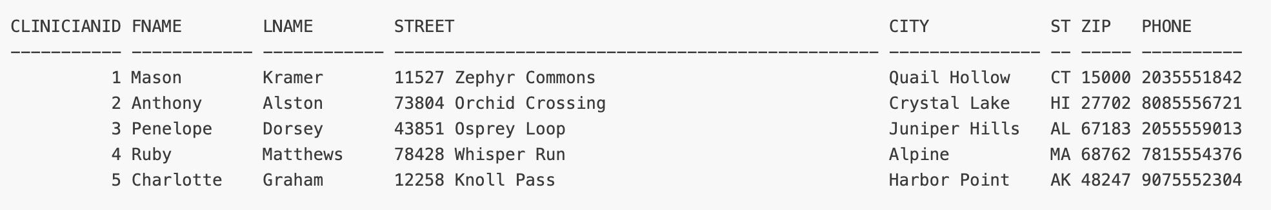

SELECT * FROM Foot

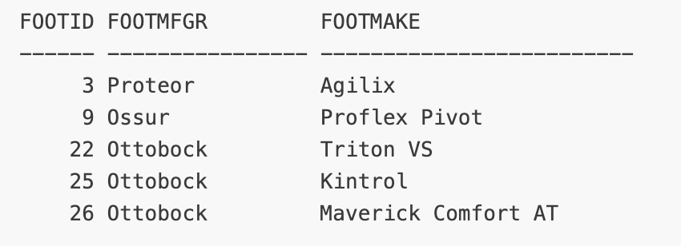

SELECT * FROM Knee
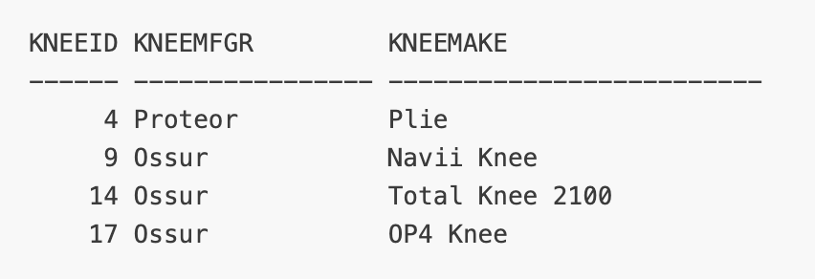

SELECT * FROM Hip
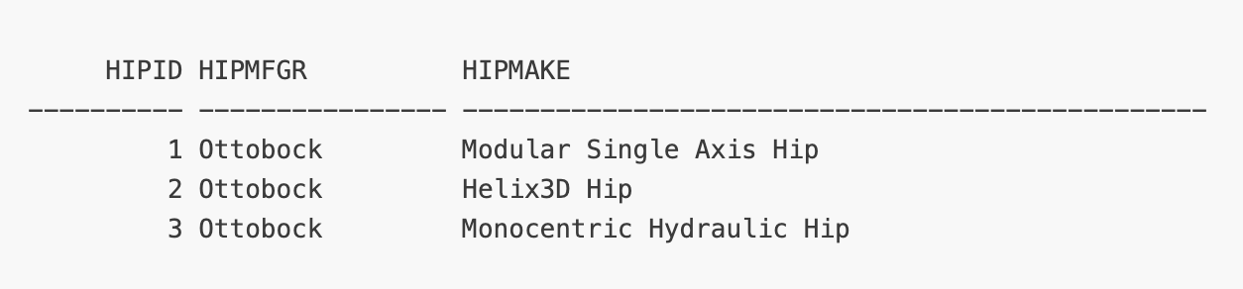

SELECT * FROM Patient
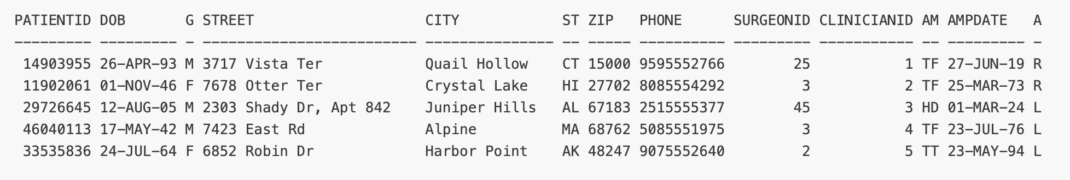
SELECT * FROM Prosthesis
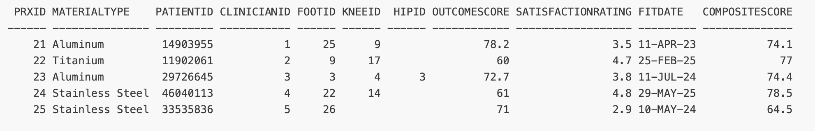

SELECT * FROM Visits
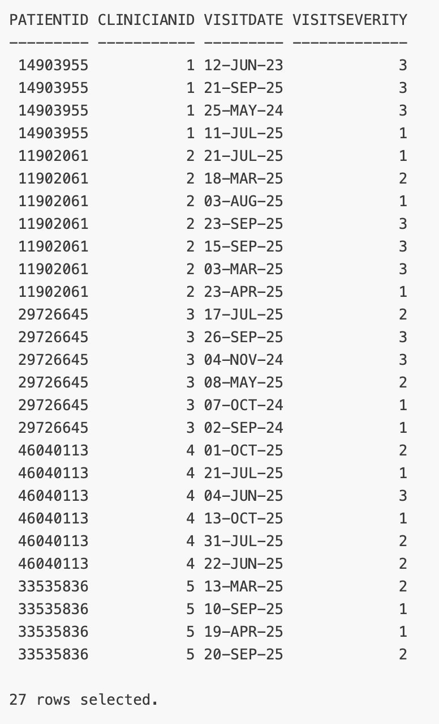

- Data Queries
  - Queries by McAllister-Spooner, Silas
Silas Query 1: Surgeon’s Patient-Gender Composite Ratings
- Business Question: What is the count of male/female patients seen by a given surgeon and what is the composite success rating of each?
- Business Reason: We want a user to be able to search for a surgeon with a greater level of experience/success across a gender demographic, both to promote communication of best practices as well as providing a resource to find the best service quickly.
SELECT
s.fname AS First_Name
s.lname AS Last_Name,
s.surgeonId AS Surgeon_ID,

SUM(CASE WHEN p.gender = 'M' THEN 1 ELSE 0 END) AS Num_Male_Patients,
SUM(CASE WHEN p.gender = 'F' THEN 1 ELSE 0 END) AS Num_Female_Patients,

AVG(CASE WHEN p.gender = 'M' THEN pr.compositeScore END) AS Avg_Composite_Male,
AVG(CASE WHEN p.gender = 'F' THEN pr.compositeScore END) AS Avg_Composite_Female

FROM surgeon s
JOIN patient p ON s.surgeonId = p.surgeonId
JOIN prosthesis pr ON p.patientId = pr.patientId
GROUP BY s.surgeonId, s.fname, s.lname
ORDER BY s.surgeonId;

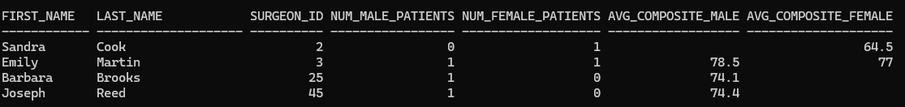

Silas Query 2: Material Usage // Amputation Severity Comparison
- Business Question: What is the count of the materials clinicians are using and the severity of amputations they are tackling?
- Business Reason: We want to determine if certain materials are being chosen more frequently and for what severity of amputation, to better inform both clinicians and manufacturers.
SELECT
c.fname AS FN,
c.lname AS LN,
c.clinicianID AS ID,

COUNT(prx.materialType) AS MAT,

SUM(CASE WHEN LOWER(prx.materialType) = 'titanium' THEN 1 ELSE 0 END) as Total_Ti,
SUM(CASE WHEN LOWER(prx.materialType) = 'aluminum' THEN 1 ELSE 0 END) as Total_Al,
SUM(CASE WHEN LOWER(prx.materialType) = 'stainless steel' THEN 1 ELSE 0 END) as Total_SS,

SUM(CASE WHEN p.ampLevel = 'TT' THEN 1 ELSE 0 END) as Total_TT,
SUM(CASE WHEN p.ampLevel = 'TF' THEN 1 ELSE 0 END) as Total_TF,
SUM(CASE WHEN p.ampLevel = 'HD' THEN 1 ELSE 0 END) as Total_HD

FROM clinician c
JOIN Patient p ON c.clinicianID = p.clinicianID
JOIN Prosthesis prx ON prx.patientID = p.patientID
GROUP BY c.clinicianID, c.fname, c.lname
ORDER BY c.clinicianID;

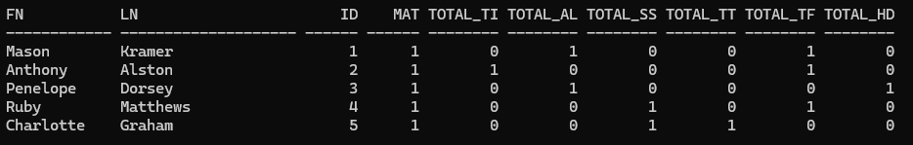
Silas Query 3: Component Location Usage
- Business Question: In what states of residence are patients using Otto Bock Feet?
- Business Reason: For manufacturers to gain knowledge of what state their products are performing the best in.
SELECT
p.patientID AS PatientID,
p.state AS State
FROM Patient p
JOIN Prosthesis prx ON p.patientID = prx.patientID
JOIN Foot f ON prx.footID = f.footID
WHERE f.footMfgr = 'Ottobock'
GROUP BY p.patientID, p.state;
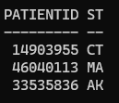

  - Queries by Muthard, Virginia
Virginia Query 1: Surgeon’s Patient Demographics
- Business Question: Who are the surgeons performing amputations on patients under 35 years old?
- Business Reason: We want a user to be able to identify surgeons based on their experience with a particular demographic population to provide reference or use as a resource to communicate services more effectively.
SELECT
s.fname AS First_Name,
s.lname AS Last_Name
FROM surgeon s
JOIN patient p ON s.surgeonid = p.surgeonid
WHERE p.dob > ADD_MONTHS(TRUNC(SYSDATE), -12 * 35);
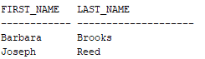
Virginia Query 2: Prosthetic Success by Amputation Level
- Business Question: Does the effectiveness (overall rating) of a prosthesis vary by amputation level?
- Business Reason: We want a user to be able to identify and sort prostheses in the database by overall rating, which could later be used to identify success of certain components for recommendation.
COLUMN amp_level HEADING 'Amp_Level' FORMAT A10
COLUMN avg_score HEADING 'Avg_Score' FORMAT 9999990.00
SELECT
p.amplevel AS Amp_Level,
ROUND(AVG(prx.compositescore),2) AS Avg_Score
FROM prosthesis prx
JOIN patient p ON prx.patientid = p.patientid
GROUP BY p.amplevel
ORDER BY Avg_Score ASC;
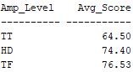

Virginia Query 3: Quantity of Materials in TF Fabrication
- Business Question: What is the quantity/count of materials being used in fabrication for Transfemoral prostheses?
- Business Reason: We want a user to be able to determine material usage from the system for a specific subset of prostheses which can be used for further analysis (e.g. financial/cost analyses).
SELECT
prx.materialtype AS Material,
COUNT(prx.materialtype) AS Mat_Count
FROM prosthesis prx
JOIN patient p ON prx.patientid = p.patientid
WHERE p.amplevel = 'TF'
GROUP BY prx.materialtype
ORDER BY Mat_Count DESC;
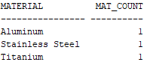
Virginia Query 4: Tracking Follow Up
- Business Question: Which patient has had the most follow-up visits and what is the quantity and who is the clinician providing service?
- Business Reason: We want a user to be able to track follow up visits to identify any inefficiencies—in componentry or clinicians—for prostheses. For clinicians with a high volume of patients with high visit counts, a discussion may be needed to identify causes and reduce inefficiencies.
COLUMN Clinician_First HEADING 'CLINICIAN_FIRST' FORMAT A15

SELECT
p.patientid AS Patient,
COUNT(v.visitdate) AS Visit_Count,
c.lname AS Clinician_Last,
c.fname AS Clinician_First
FROM patient p
JOIN visits v ON p.patientid = v.patientid
JOIN clinician c ON p.clinicianid = c.clinicianid
GROUP BY
p.patientid,
c.lname,
c.fname
HAVING COUNT(v.visitdate) = (
SELECT MAX(COUNT(v.visitdate))
FROM visits vs
GROUP BY vs.patientid
);
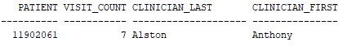

  - Queries by Roman, Phillip
Phillip Query 1: Long-Term Material Satisfaction
- Business Question: Which prosthetic materials receive the highest satisfaction ratings from patients with long-term care histories (4+ visits)?
- Business Reason: We wanted to understand which prosthetic materials perform best for patients who demonstrate long-term commitment to their care. Filtering for at least 4 visits ensures our analysis reflects real-world, sustained use rather than initial impressions.
SELECT
prx.materialType AS Material_Type,
COUNT(DISTINCT v.visitDate) AS Number_of_Visits,
COUNT(DISTINCT pat.patientId) AS Number_of_Patients,
ROUND(AVG(prx.satisfactionRating), 2) AS Avg_Satisfaction,
ROUND(AVG(prx.outcomeScore), 2) AS Avg_Outcome_Score
FROM Prosthesis prx
JOIN Patient pat ON prx.patientId = pat.patientId
JOIN Visits v ON pat.patientId = v.patientId
WHERE pat.patientId IN (
SELECT patientId
FROM Visits
GROUP BY patientId
HAVING COUNT(visitDate) >= 4
)
GROUP BY prx.materialType
ORDER BY Avg_Satisfaction DESC, Avg_Outcome_Score DESC;
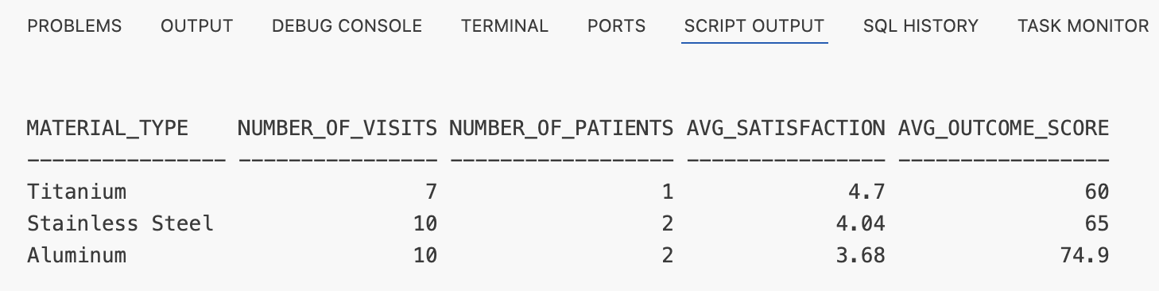

Phillip Query 2: Outcomes by Amputation Level & Age
- Business Question: How do composite scores compare across amputation levels when factoring in patient age at the time of amputation?
- Business Reason: Comparing average composite scores alongside patient ages (current and at amputation) helps identify if certain amputation levels work better for specific age groups. This data helps surgeons set appropriate expectations and choose optimal amputation levels.
SELECT
CASE pat.ampLevel
WHEN 'TT' THEN 'Transtibial'
WHEN 'TF' THEN 'Transfemoral'
WHEN 'HD' THEN 'Hip Disarticulation'
END AS Amputation_Level,
COUNT(pat.patientId) AS Number_of_Patients,
ROUND(AVG(TRUNC(MONTHS_BETWEEN(SYSDATE, pat.dob) / 12)), 1) AS Avg_Current_Age,
ROUND(AVG(TRUNC(MONTHS_BETWEEN(pat.ampDate, pat.dob) / 12)), 1) AS Avg_Age_At_Amputation,
ROUND(AVG(pros.compositeScore), 2) AS Avg_Composite_Score
FROM Patient pat
JOIN Prosthesis pros ON pat.patientId = pros.patientId
GROUP BY pat.ampLevel
ORDER BY Avg_Composite_Score DESC;
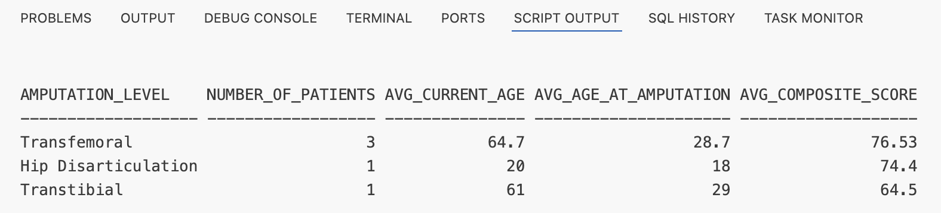
Phillip Query 3: High-Severity Patient Flagging
- Business Question: Which patients have an average visit severity score that exceeds the overall clinic average?
- Business Reason: Identifying patients with serious ongoing issues by flagging those whose average visit severity exceeds the overall average allows the clinic to prioritize care for high-severity cases rather than focusing solely on visit frequency.
SELECT AVG(visitSeverity) AS Overall_Avg_Severity
FROM Visits;

SELECT
pat.patientId AS Patient_ID,
pat.gender AS Gender,
TRUNC(MONTHS_BETWEEN(SYSDATE, pat.dob) / 12) AS Age,
ROUND(AVG(v.visitSeverity), 2) AS Avg_Visit_Severity,
COUNT(v.visitDate) AS Total_Visits
FROM Patient pat
JOIN Visits v ON pat.patientId = v.patientId
GROUP BY pat.patientId, pat.gender, pat.dob
HAVING AVG(v.visitSeverity) > (
SELECT AVG(visitSeverity)
FROM Visits
)
ORDER BY Avg_Visit_Severity DESC;

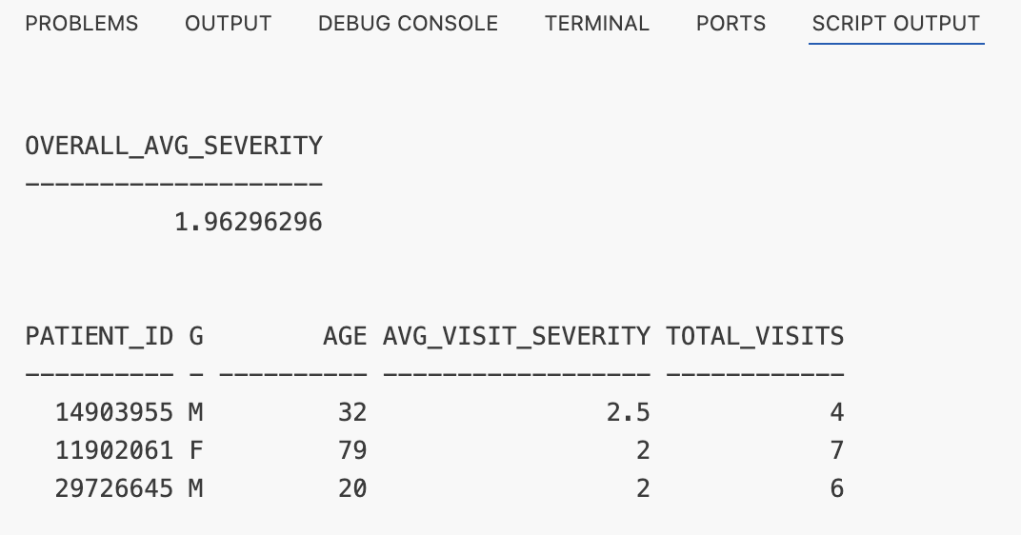

- Data Manipulation
  - DML by McAllister-Spooner, Silas
Silas DML 1: Mistyped Address Correction - UPDATE
- Business Reason: A patient (ID 11902061) had their address entered incorrectly and needs it to be corrected for insurance and billing purposes.
SELECT
patientid,
street,
city,
state

FROM patient
WHERE patientID = 11902061;

UPDATE patient
SET street = '1500 Spruce ST', city = 'Philadelphia', state = 'PA'
WHERE patientID = 11902061;

SELECT
patientid,
street,
city,
state

FROM patient
WHERE patientID = 11902061;

ROLLBACK;
BEFORE:
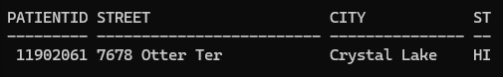
UPDATE:
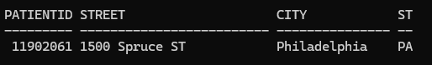
ROLLBACK:
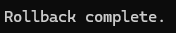
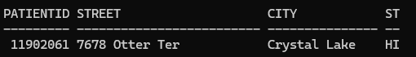

Silas DML 2: Delete Records of Patients Residing in Alaksa – DELETE
- Business Reason: Due to a change in legality of record keeping in the state, all Alaska patient records must be dropped for the time being to meet compliance standards.
SELECT patientId,State from Patient WHERE state = 'AK';
SELECT p.patientID,prx.fitDate from Prosthesis prx JOIN Patient p ON prx.patientId = p.patientId WHERE p.state = 'AK';
SELECT p.patientID, v.visitDate from Visits v JOIN Patient p ON v.patientId = p.patientId WHERE p.state = 'AK';

DELETE FROM Visits
WHERE patientId IN (
SELECT patientId FROM Patient WHERE state = 'AK');

DELETE FROM Prosthesis
WHERE patientId IN (
SELECT patientId FROM Patient WHERE state = 'AK');

DELETE FROM Patient
WHERE state = 'AK';

SELECT patientId,State from Patient WHERE state = 'AK';
SELECT p.patientID,prx.fitDate from Prosthesis prx JOIN Patient p ON prx.patientId = p.patientId WHERE p.state = 'AK';
SELECT p.patientID, v.visitDate from Visits v JOIN Patient p ON v.patientId = p.patientId WHERE p.state = 'AK';

ROLLBACK;

BEFORE:
Patient Relation Prosthesis Relation Visits Relation
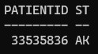 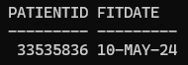 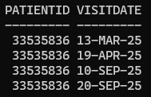
UPDATE:
Patient Relation Prosthesis Relation Visits Relation
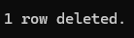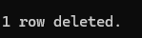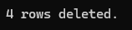
 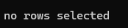
ROLLBACK:
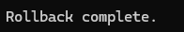
Patient Relation Prosthesis Relation Visits Relation
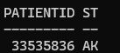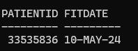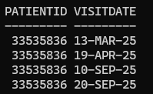

  - DML by Muthard, Virginia
Virginia DML 1: New Phone Number (UPDATE)
- Business Reason: A patient (ID 14903955) now has a new phone number and it must be updated within the system.
SELECT
patientid,
dob,
phone
FROM patient;

UPDATE patient
SET phone = '9592001234'
WHERE patientid = 14903955;

SELECT
patientid,
dob,
phone
FROM patient;

ROLLBACK;
BEFORE – UPDATE – ROLLBACK:
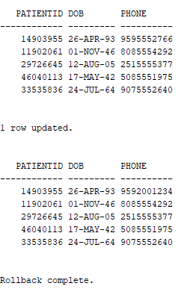

Virginia DML 2: Deceased Patient (DELETE)
- Business Reason: A patient (ID 14903955) has passed away and must be removed from the system.
SELECT
patientid,
dob,
phone
FROM patient;

DELETE FROM prosthesis
WHERE patientid = 14903955;

DELETE FROM visits
WHERE patientid = 14903955;

DELETE FROM patient
WHERE patientid = 14903955;

SELECT
patientid,
dob,
phone
FROM patient;

ROLLBACK;

BEFORE – UPDATE – ROLLBACK:
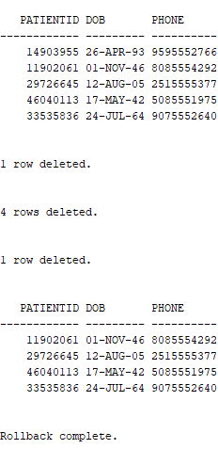

  - DML by Roman, Phillip
Phillip DML 1: Clinician Reassignment (Update)
- Business Reason: A patient (ID 33535836) must be reassigned to a new clinician (ID 2) because their previous clinician is retiring from the practice.
SELECT patientid, clinicianid, phone
FROM patient
WHERE patientid = 33535836;

UPDATE patient
SET clinicianid = 2
WHERE patientid = 33535836;

SELECT patientid, clinicianid, phone
FROM patient
WHERE patientid = 33535836;

ROLLBACK;
Before UPDATE Statement:
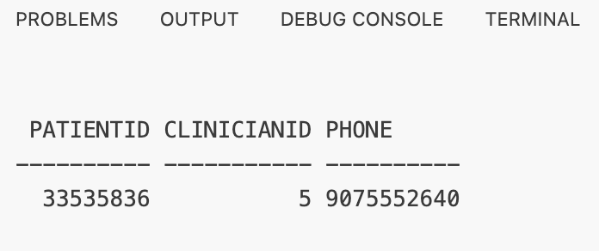
After UPDATE Statement:
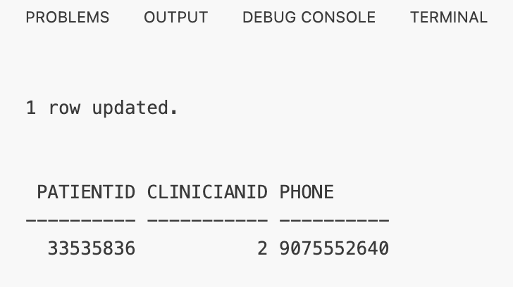

Phillip DML 2: Discontinued Inventory (Delete)
- Business Reason: The 'Modular Single Axis Hip' (Model ID 1) has been discontinued by the manufacturer. Since it is not currently implanted in any active patients, we are removing it from the approved parts database to prevent future selection.
SELECT * FROM Hip WHERE hipId = 1;

DELETE FROM Hip WHERE hipId = 1;

SELECT * FROM Hip WHERE hipId = 1;

ROLLBACK;
Before DELETE Statement:

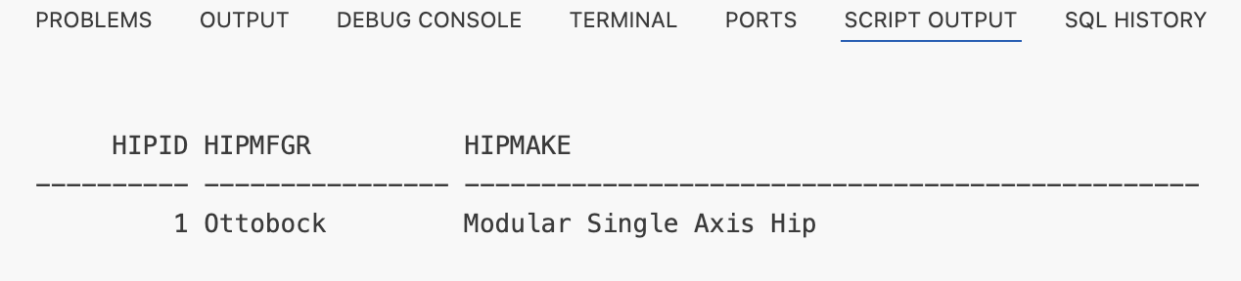

After DELETE Statement:

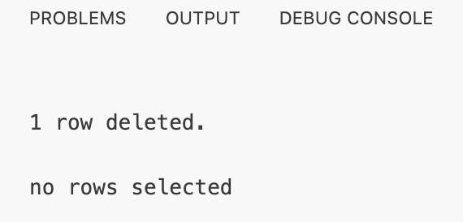

- Summary
  - Summary by McAllister-Spooner, Silas
The process of completing this project provided a great opportunity for me to gain insight into the workflow process and value of domain expertise when approaching the creation of an effective database. The initial ideation phases, and approaching the construction of the ERD, were particularly effective in highlighting just how important knowledge of subject matter is when defining the best scope and approach to a database. We went through several proposed structures for the ERD and database before settling on the current iteration. This process taught me a significant amount about Schema creation and early database planning. The application of the database in SQL afforded me the opportunity to experiment with SQL on a windows computer. Down the line, I am eager to see how the different applications a database of this kind would look in terms of process of creation and implementation. This project reflected the process that I intend to udnergo in a future project, where I aim to create a music popularity prediction model based off of a database of queueable Spotify metrics. Seeing the ways in which we iterated on the idea as time passed using Virginia’s business knowledge of the domain inspired me into the way in which I can incorporate my own expertise in developing this future project. If we had greater amounts of time in this project and access to a larger / real dataset, I would be interested to see how feasible processing the data would be with our schema. Since our data was created directly for this use, we were able to avoid unforseen pitfalls that real,messier data might provide.
  - Summary by Muthard, Virginia
Completing this project allowed for exploration of the use of a database within business context. As the weeks passed, I was not only able to identify more ways for which the scope of the project could be expanded for practical business use, but also other areas within my organization where similar database usage would directly aid our team. If there was more time for this specific project, I would want to import a larger dataset of patients, clinicians, etc. in order to produce more complex and meaningful query results. I would also like to build out the system to have a knowledge-based recommender component that would enable a user (perhaps within a set View) to query the system for the top recommended components for their particular patient of interest. In order to complete this task, though, it would require bringing over a much larger set of data than was requested in this project. I look forward to taking the lessons and skills practiced in this project into my department, utilizing them for inventory management and component tracking with respect to our patient models and equipment. This structure would allow easier component matching for patient models with simple queries and can help track who is using what component—including a checkout/checkin process. I have much appreciation for the utility of the knowledge gained in this course project.
  - Summary by Roman, Phillip
This project provided a first-hand experience of the complexity of translating real-world clinical workflows into a rigid relational schema. The first instance occurred when applying our defined business rules to Conceptual ERD’s constraints and cardinality. A key lesson learned was that defining scope is a double-edged sword. While strict business rules maintain integrity, they can inadvertently hinder data insertion if the domain model is too narrow. I also deepened my understanding of ERD modeling, specifically in distinguishing between aggregation and super/subclass structures by applying "has-a" versus "is-a" guidelines to our prosthetic components. From a technical perspective, I successfully navigated the challenges of running Oracle Database on macOS by utilizing Docker containers to establish a stable SQL Developer environment. Furthermore, handling referential integrity constraints during data deletion highlighted the critical importance of order-of-operations in database management. If we had more time, I would load the complete synthetic dataset to rerun our queries and analyze genuine clinical correlations in a larger sample size.

- Appendix
  - Division of Work
Silas McAllister-Spooner
- Designed the initial ERD for the Project Proposal.
- Collaborated on refining the Data Dictionary.
- Collaborated on refining the CREATE TABLE statements.
- Authored individual SQL Queries, DML statements, and Summary.
Virginia Muthard
- Developed the Referential Integrity Schema.
- Compiled the majority of the Data Dictionary.
- Wrote the INSERT statements for the dataset.
- Initiated the Final Report and contributed key sections.
- Authored individual SQL Queries, DML statements, and Summary.
Phillip Roman
- Refined the ERD into the final Conceptual and Logical models for this report.
- Authored the majority of the CREATE TABLE statements.
- Collaborated on refining the Data Dictionary.
- Compiled and formatted the Final Report document.
- Authored individual SQL Queries, DML statements, and Summary.

